**William.M.Vories Architectures Sightseeing**

**＊Tourism Inquiries :**

**JR(Japan Railway) Ohmihachiman Station**

**North Side, Ohmihachiman Tourist**

**Information Center**

**TEL : 0748-33-6061**

**FAX : 0748-32-4125**

**Home Page : Ohmihachiman Tourism Association**

**http://www.omi8.com**

**Recommending Route**

**Required Time : About 2 hours**

**Walking Distance : About 3 ｋｍ**

**Starting Point : Municipal Obata sightseeing parking**

**-Start-**

**Obata Sightseeing Parking**

**About 40min. (by foot)**

Water House

**Ikedamachi Western-Style Houses Street**

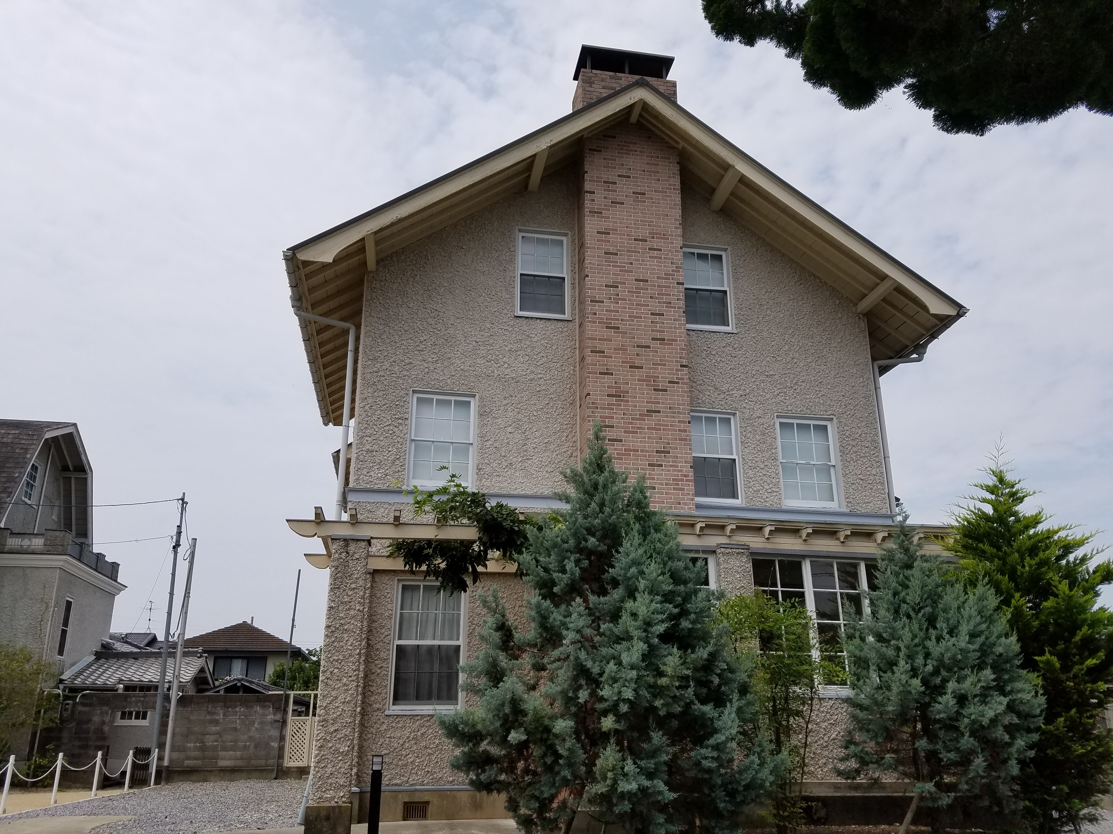

**Double House**

**Waterhouse Memorial Hall**

Special Public Open in Spring & Autumn

(by Charge)

**Former Mr. Etsuzo Yoshida House**

Andrews Memorial Hall

**Hachiman Commercial Senior High School Street**

W.M.Vories came over to Ohmihachiman

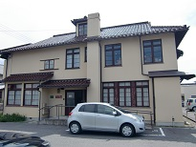

for English teacher in this high school.

Named as the Andrews of intimate friend

**Andrews Memorial Hall**

Special Public Open in Spring & Autumn

(by Charge)

Vories Architecture of semi-Western Style

**Muraoka House (The Former Iwase Clinic)**

Western-Style House used for the Clinic.

　　　　　　　　　　　　　　　　　　　　　　　　　　　Entrance required by reservation in advance.

**Vories Memorial Home**

Built for the dormitory of Ohmibrotherhood

Vories Memorial Home

School at first,Mr.&Mrs.Vories lived in end.

**About 5min. (by foot)**

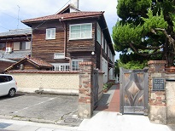

**(Abt 40min)**

**Hyde Memorial Hall**

This kindergarten built by contribution of

Mr.Hyde who was founder of USA

**About 10min. (by foot)**  　 Mentholatum.

**(Abt 10min)**

Entrance (Free of charge). Attention of

**The Former Hachiman Post Office**

Closed day.

Vories Statue

**About 25min. (by foot)** Post Office built by Mr.Vories Architecture

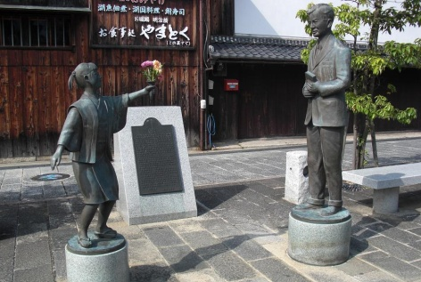 on 1921(Taisho 10 yr.)

**Menturm Museum**

**Vories Statue**

Statues of Mr.Vories and girl gives flower

to him.

**(Abt 25min)**

**Obata Sightseeing Parking**

**-Goal-**