
William.M.Vories Architectures Sightseeing
＊Tourism Inquiries :
JR(Japan Railway) Ohmihachiman Station
North Side, Ohmihachiman Tourist
Information Center
TEL : 0748-33-6061
FAX : 0748-32-4125
Home Page : Ohmihachiman Tourism Association
http://www.omi8.com

Recommending Route
Required Time : About 2 hours
Walking Distance : About 3 ｋｍ
Starting Point : Municipal Obata sightseeing parking
-Start-
Obata Sightseeing Parking
About 40min. (by foot)
Water House
Ikedamachi Western-Style Houses Street

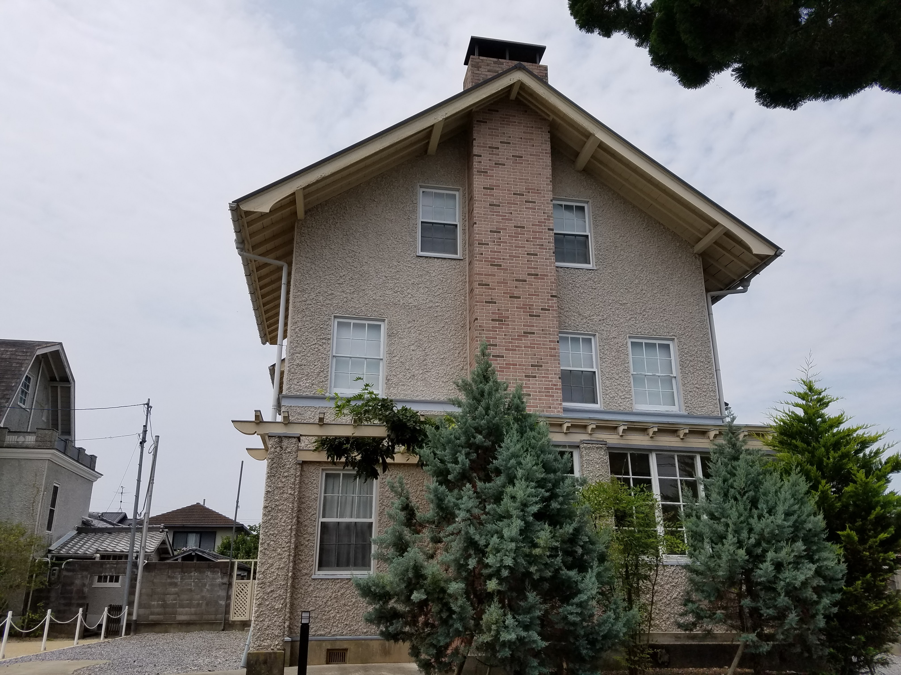

Double House

Waterhouse Memorial Hall
Special Public Open in Spring & Autumn
(by Charge)
Former Mr. Etsuzo Yoshida House

Andrews Memorial Hall
Hachiman Commercial Senior High School Street

W.M.Vories came over to Ohmihachiman
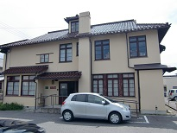
for English teacher in this high school.
Named as the Andrews of intimate friend
Andrews Memorial Hall

Special Public Open in Spring & Autumn
(by Charge)
Vories Architecture of semi-Western Style
Muraoka House (The Former Iwase Clinic)

Western-Style House used for the Clinic.

Entrance required by reservation in advance.
Vories Memorial Home

Built for the dormitory of Ohmibrotherhood
Vories Memorial Home

School at first,Mr.&Mrs.Vories lived in end.
About 5min. (by foot)
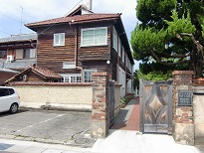
(Abt 40min)
Hyde Memorial Hall
This kindergarten built by contribution of
Mr.Hyde who was founder of USA
About 10min. (by foot) Mentholatum.

(Abt 10min)
Entrance (Free of charge). Attention of
The Former Hachiman Post Office
Closed day.
Vories Statue
About 25min. (by foot) Post Office built by Mr.Vories Architecture
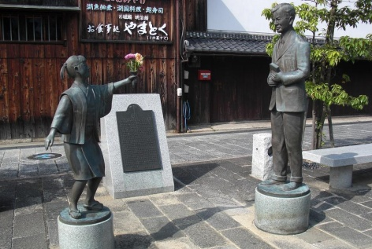
on 1921(Taisho 10 yr.)
Menturm Museum

Vories Statue

Statues of Mr.Vories and girl gives flower
to him.
(Abt 25min)
Obata Sightseeing Parking

-Goal-

